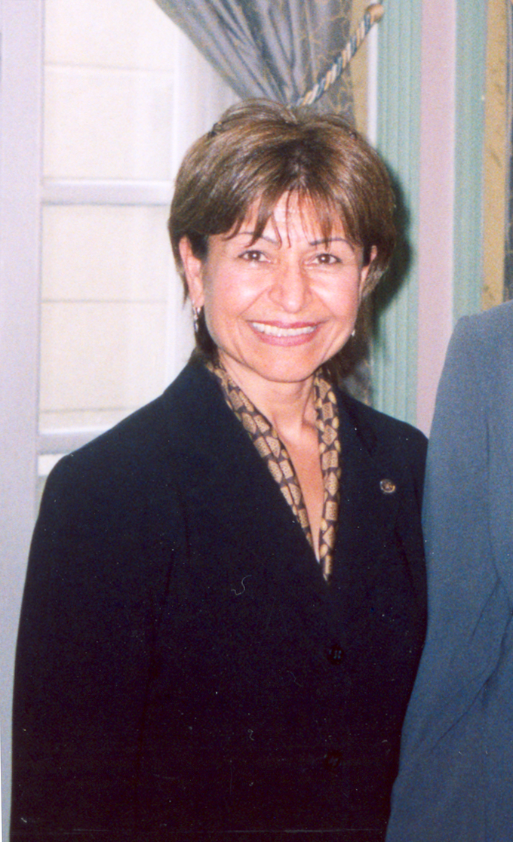
Fary Moini

P.O. Box 910617
San Diego, CA 92191
Cell (858) 610-1174
E-mail: farym@att.net
March, 1, 2013

Profession Experience
Moini International Consulting (MIC), President-- Recent Contracts in Afghanistan includes:
- Contract with San Diego State University Research Foundation (SDSU) to provide consulting services to SDSU Partnership with Nangarhar University (NU) to build English language capacity at NU funded by World Bank
- Contract with SDSU to provide consulting services to SDSU Partnership with NU to build civil engineering and construction capacity at NU funded by World Bank
- Contract with San Diego~Jalalabad Sister Cities Foundation to provide consulting services for e-Quality Alliance Program’s ANGeL Center at NU Medical School funded by Washington State University
- Contract with La Jolla Golden Triangle Rotary Club Foundation (LJGTRCF) to provide consulting services for the Global Connection and Exchange Program funded by the U.S. Department of State’s Bureau of Educational and Cultural Affairs.
- Contract with LJGTRCF to provided consulting services under Light Up Jalalabad Program funded by USAID’s Afghanistan Small and Medium Size Enterprise Development program
- Contract with NATO for Networking Infrastructure Grant to distribute broadband internet connectivity throughout NU’s main campus and four satellite locations
- Contract with State Deaprt,ment for Jalalabad Female Sport Association. Providing Table Tennis & volley ball to 8 female schools 2012-2013.

Rotary International’s representative to U.S. National Commission to UNESCO 2005-2010
Activities include:
• Keep UNESCO advised of Rotary activities
• Provide information to Rotary regarding UNECSO activities
• Serve on the Education Committee
• Advise regarding opportunities for Rotary Clubs to collaborate with UNESCO

Volunteer Experiences
Rotary Foundation Volunteer --Don Bosco Boys School Nairobi, Kenya 7/1//2005
Activities included:
• Assisting in medical clinic
• Teaching first aid
• Teaching English
• Evaluating and purchasing safety equipment
• Field trips with students

Rotary Foundation Volunteer --Jalalabad, Afghanistan 11/2003—3/2004
Activities included:
• Overseeing development of Rotary school and computer lab for 3500 students
• Overseeing installation of satellite based computer lab at Nangarhar University
• Coordinated distribution of 12,000 English dictionaries in Afghanistan
• Assisted in Jalalabad in arranging Sister Cities relationship between Jalalabad and San Diego
• Assisted in chartering the Rotary Club of Jalalabad.
• Assisted in selection process in bring university professors and high school teachers from Jalalabad to San Diego
Under Rotary’s Group Study Exchange Program (2005 and 2009)
- Assisted in selection process in bring University professors from Nangarhar university to San Diego State University under World Bank for training in ESL and Engineering.
Rotary Foundation Peshawar, Pakistan 01/2002 – 05/2002
Volunteer Nurse (OBG)
• Assisted doctors in delivery cases in the clinics established by Rotary International for
Afghan Refugees, in Peshawar, Pakistan.
• Facilitated as an interpreter for the local Farsi speaking patients and doctors with
Language barriers.
• Taught refugees about basic health and hygiene, trained the camp staff in providing better
health and living conditions.
• Set up and maintain the equipment and facilities for the patients. As a team member
worked on several projects to improve the basic living conditions for the refugees.
- Oversee and furnishing the construction of two buildings Steve Brown International Center and guest house at the Nangarhar University.
- Oversee the construction of Girl’s Dormitory at the Nangarhar University.

Former Business Interests
VIP Formals San Diego 01/91 – 11/04 Owner/Operator
• Managed two branches of formal attire shops.
• Handled the day-to-day operations and managed a staff of 6-10 employees.
• Provided customer service, marketing issues, employee schedules and company
representatives/consultants.
• Make purchasing forecasts, inventory, accounts and advertising.

Dubai Medical Center Dubai, UAE 02/79 – 04/82 Chief Nurse
• Managed a staff of over one hundred nurses and technicians at two hospitals.
• Maintain schedules, oversaw the staff in the wards, regular interaction and dealing with
higher management/doctors.

Prime Medical Clinic Silver Spring, Maryland US 03/84 – 06/90
Staff Nurse
• Assisted doctors in general practice.
• Patient’s examination, registering, monitoring the vital signs.
• Perform cardiograms, transfusions; follow up patient’s treatment plans.

Teaching Experience
ESL teacher Nangarhar, University, Jalalabad, Afghanistan 12/04-3/04
Espand-Mehr School of nursing Kerman, Iran 03/76 – 08/80 Assistant-Dean
• Taught courses in internal medicine to student nurses.
• Taught first-aid to the public.
• Supervise and maintain schedules for teachers in the department. Arranged
Seminars for the school.
Education
San Diego State University-American Language Institute
Teaching English as a Foreign Language 10/05
UCSD Extension Classes re teaching ESL 9/04
Bachelors of Science in Nursing 12/1971
University of Tehran, Tehran Iran
Memberships
Board Member, La Jolla Golden Triangle Rotary Club.
Chair Community Services, La Jolla Golden Triangle Rotary Club.
Board Member, House of Iran Cultural Organization.
Board Member of Sister city San Diego/ Jalalabad Afghanistan.

Languages
Fluent in English and Farsi/Dari

Awards
Life-time Achievement Award-Hometown hero-- Lifetime Channel
Recognition by the White house, champion of change 2012
One of Fifty People to watch in San Diego—San Diego Magazine
Rotarian of the year—Rotary District 5340 2002-03
Recognition Award, Lt. Governor State of California.
Recognition Award, San Diego Press Club.
Recognition Award from Salvation Army women of dedication Feb. 24, 2011
Recognition award from Rotary District 5300 as peace Maker 2011
Recognition Award, Soroptimist International of Rancho Bernardo, San Diego.
Recognition Award, Shelter Island Rotary Club, San Diego as peace maker of the year 2008.
Recipient of LA MANCHA Human Rights Advocate award from Casa Cornelia Law Firm 2009
Recognition Award from Girls Scout’s cool woman of the year 2009.

